**Shri Ramdeobaba College of Engineering and Management, Nagpur**

**Department of Electronics Engineering**

**Digital Image Processing (ENT 355-3)**

**Name:** Prajwal Pandurang Shette

**Roll No:** B1- 12

**Experiment No: 04**

**Aim**: Experiments on Virtual lab

i. Image Arithmetic, ii. Point Operations, iii. Neighbourhood Operations,

iv. Image Histogram, v. Fourier Transform, vi. Image Segmentation,

vii. Morphological Operation

1. **Image Arithmetic**

**Aim:** In image arithmetic, we consider operations such as I(x,y) = A (x,y) o B(x,y) where o is an arithmetic operation such as addition, subtraction, multiplication or division. Here, A and B could be derived from different sources. Such operations are particularly used in modelling image acquisition as a result of a perfect image corrupted with (additive or multiplicative) noise. The noise is often introduced either by a transmission medium or the camera.

**Objective:**

1. To learn to use arithmetic operations to combine images.
2. To study the effect of these operations on the dynamic range of the output image.
3. To study methods to enforce closure - force the output image to also be an 8 bit image.
4. **Addition :**



1. **Subtraction:**

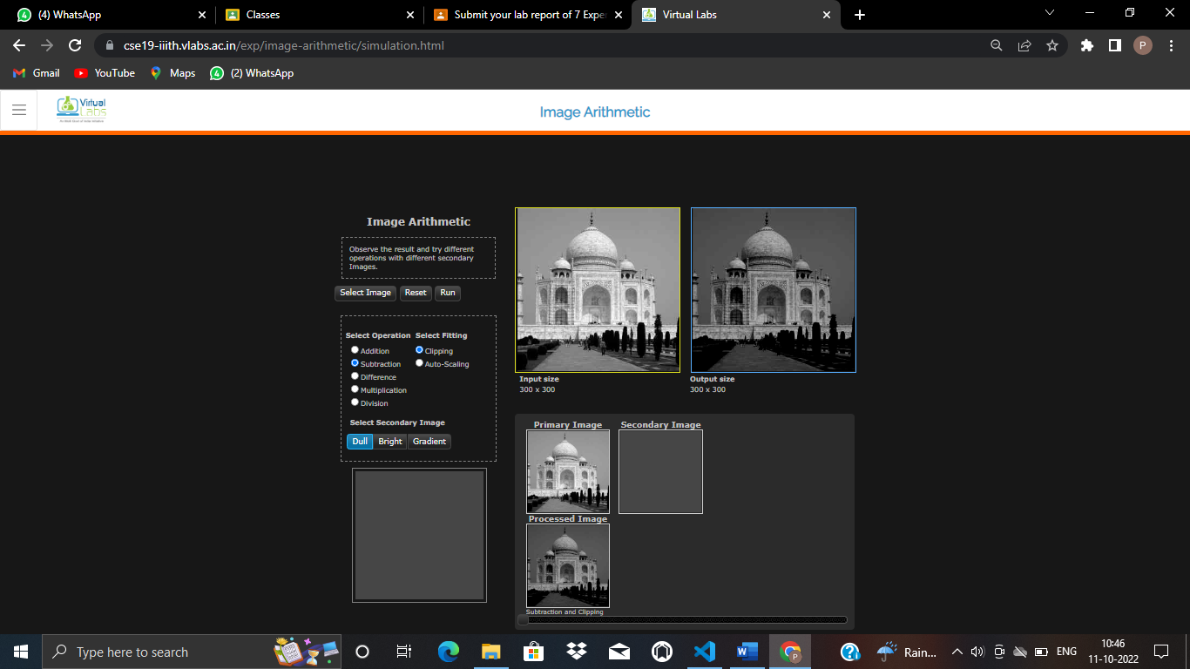

1. **Difference**:



1. **Multiplication:**

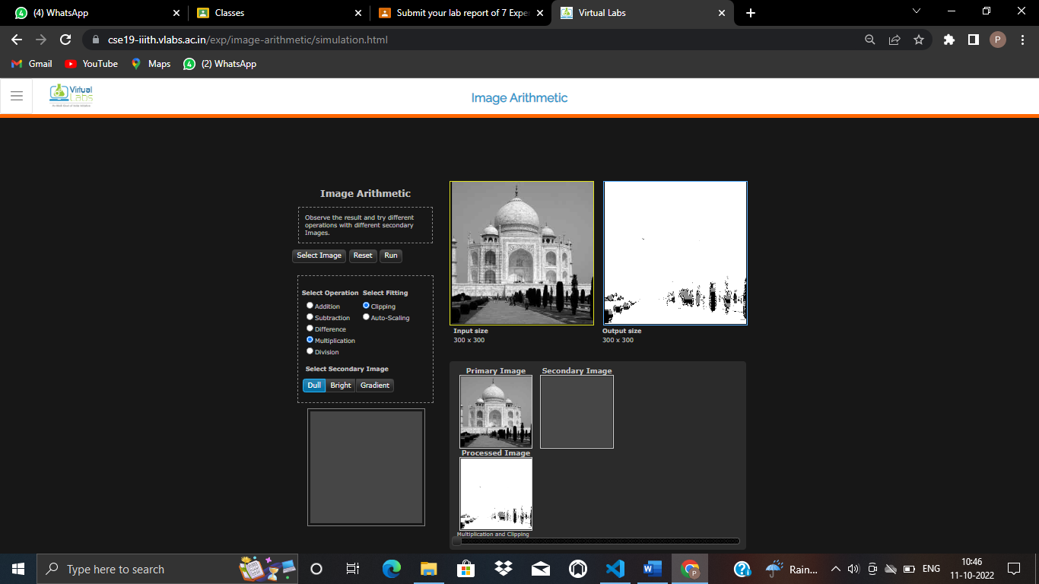

1. **Division**:

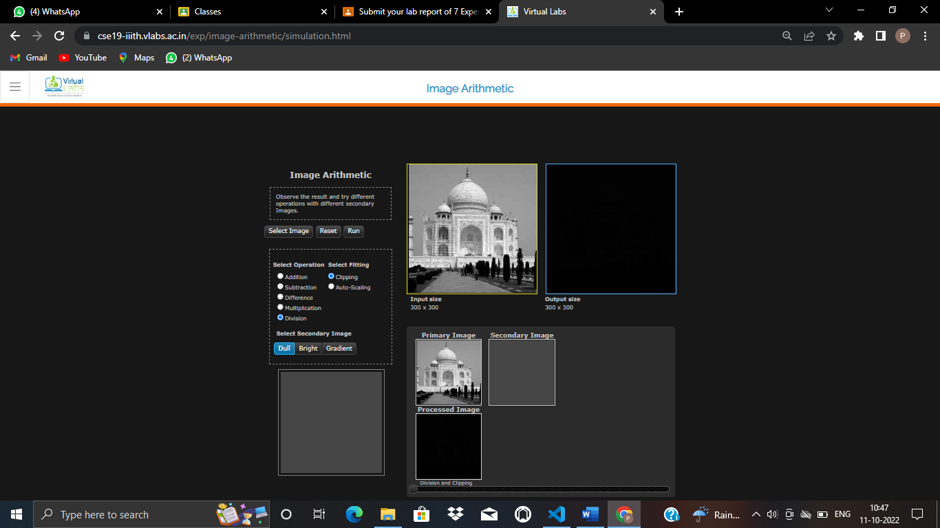

1. **Point Operations**

**Aim :** The most popular application of image processing is to change the visual appearance of the image such as to improve the contrast, reduce the dynamic range of brightness, reverse the 'polarity' such as dark to white and vice versa.

**Objective:** To learn image enhancement through point transformation

i.Linear transformation  
 ii. Non-linear transformation  
iii. Clipping (piecewise linear)  
iv. Gray level windowing

**Theory**: Point operations are simple image enhancement techniques. Here, the operations are directly performed on the pixel values. A given image f(x,y) is transformed into an output image g(x,y) using some transformation T. Let f(x,y) = p and g(x,y) = q; p and q are also known as pixel values in the corresponding images at location (x,y). Thus,

q = T(p)

where, T is a transformation that maps p into q. The results of this transformation are mapped into the grey scale range as we are dealing here only with grey scale digital images. So, the results are mapped back into the range [0, 255].

There are four commonly used and basic types of functions (transformation) are described here:

1. Linear function
2. Non-linear function
3. Clipping
4. Window function

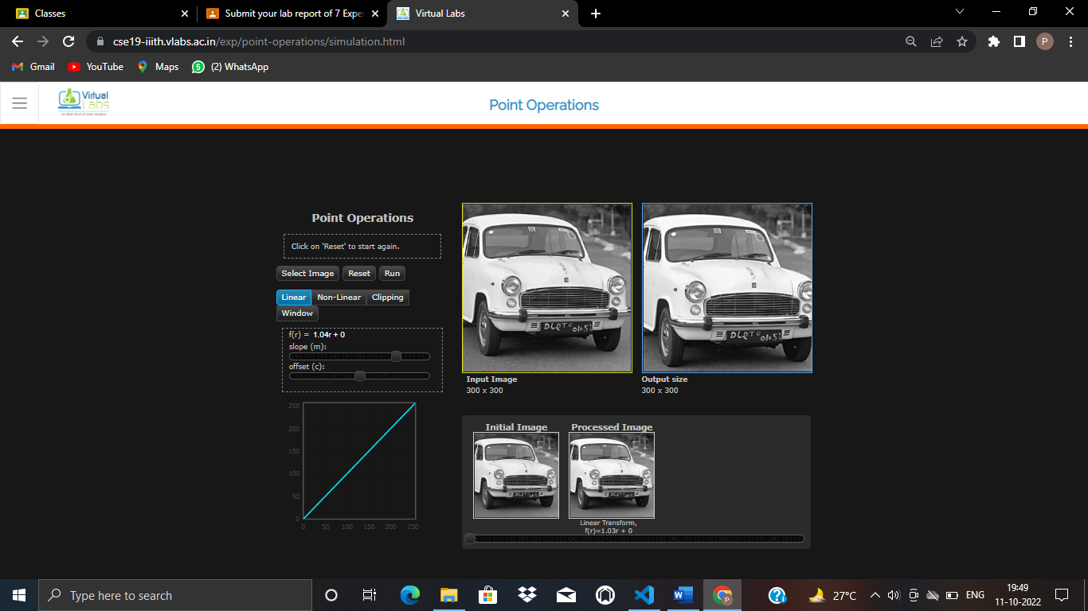

1. **Neighbourhood Operations**

**Aim :** Neighbourhood operations are a generalization of the point operations. A pixel in the processed image now depends not only on the corresponding pixel in the input image but also its neighbouring pixels. This generalization also allows for defining linear as well nonlinear filtering operations.

**Objective:**

1. To learn about neighbourhood operations and use them for i. Linear filtering ii. Non-linear filtering
2. To study the effect of the size of neighbourhood on the result of processing

**Theory:**

Given an input image f(x,y) an output image g(x,y) is computed by applying some operation on a local neighbourhood N of each pixel in the image f. This can be visualized as follows: a window or mask is placed at every pixel location in f(x,y) and some operation is performed on the pixels within the window. The window is moved to the next pixel location nd the process is repeated. Thus,



Where HN is the neighborhood operator of size N and g is the output image.

**Linear operations :**

Linear operations can be represented as a convolution operation between f(x,y) and a window function w(x,y) as follows.



w is a window function which in practice is in the form of a matrix of size s x t; a=(s-1)/2 and b=(t-1)/2 .

An example of 3x3 w(x,y) is shown below.

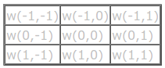

An example of convolution operation is shown below:

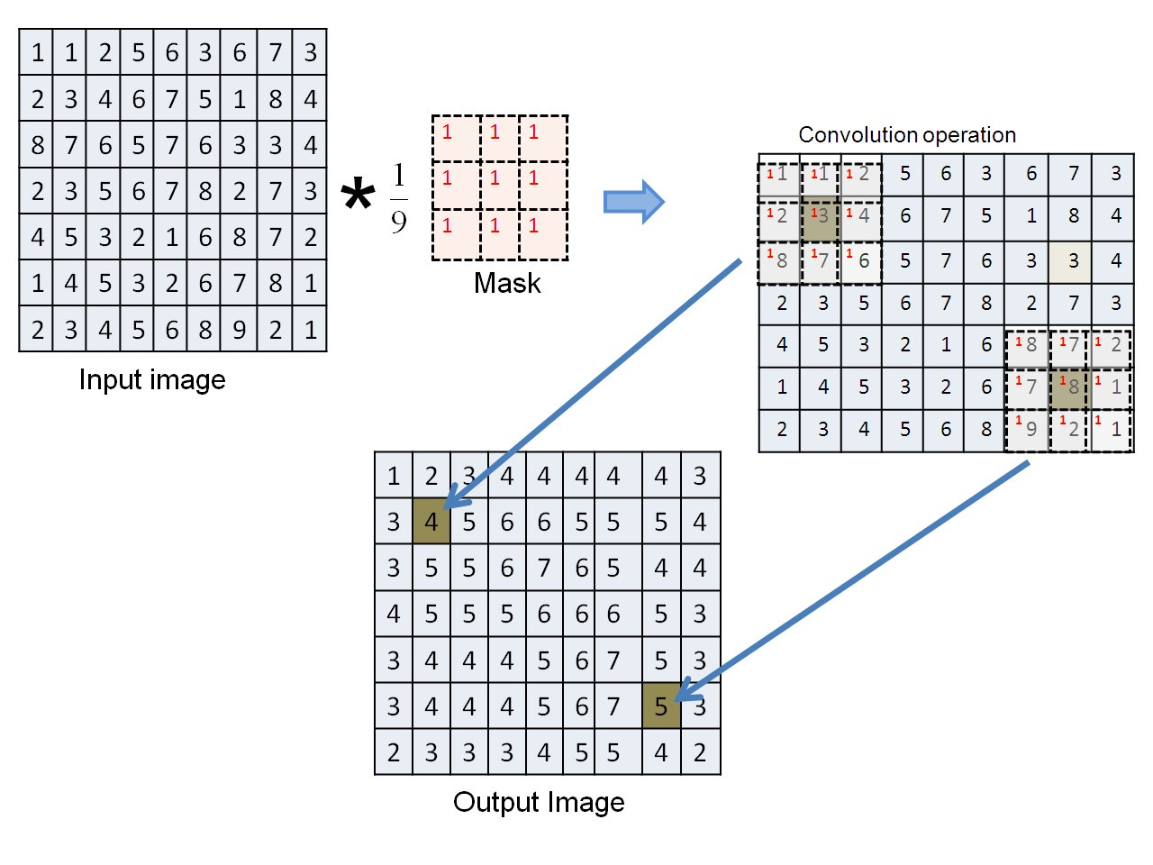

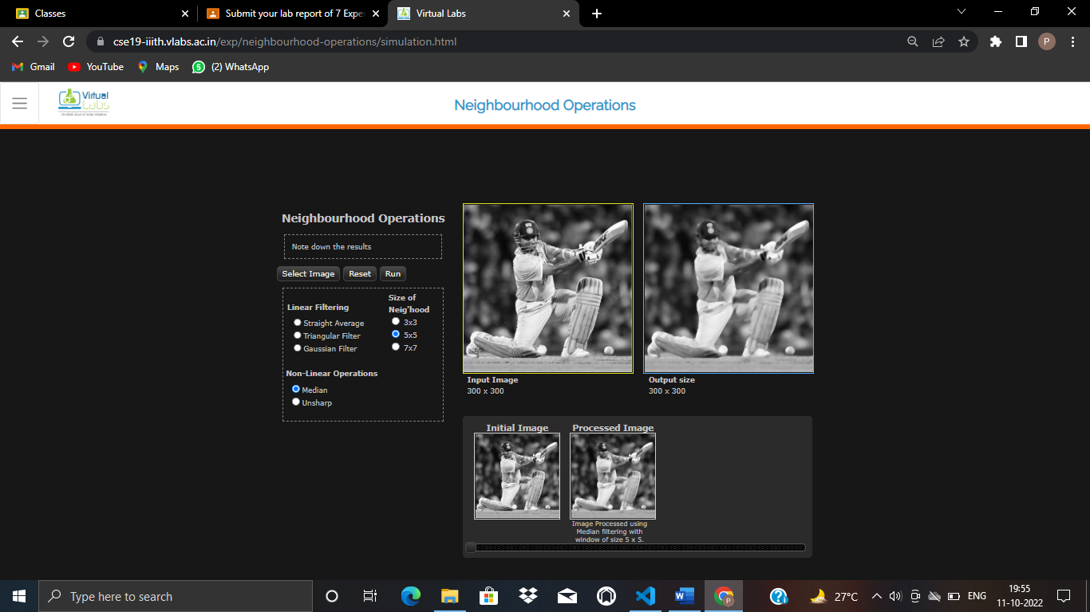

1. **Image Histogram**

**Aim:** A histogram of an image represents the distribution of pixel intensities in the image. Histograms provide statistical information about the image.

**Objective:**

1. To understand how frequency distribution can be used to represent an image.
2. To study the correlation between the visual quality of an image with its histogram.

**Theory:**

Given an image A, its histogram H(k) is derived by counting the number of pixels at every grey level k.

H(k) = Nk k = 0,1,2.....K-1.

where Nk is the count of pixels at gray level k. The total number of bins in this histogram is K . Theoretically, the maximum value for K is determined by the pixel depth M of the image. For instance, for an M=8-bit greyscale image, we can have up to 2M = 256 = K bins and for a binary image (1-bit) we can have just 2 bins.

Sometimes, the value of K is chosen to be different from2M. This will alter the appearance of the histogram. The example below illustrates this effect.

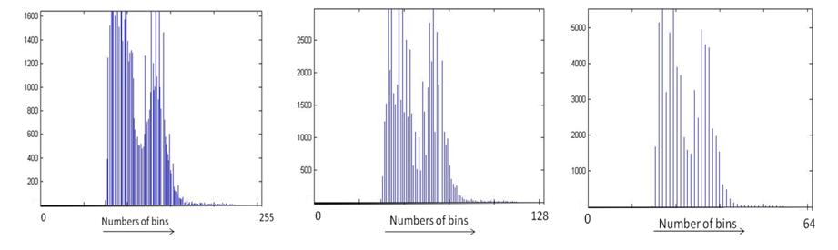

The histogram of an image is a good indicator of the contrast and brightness of a given image.

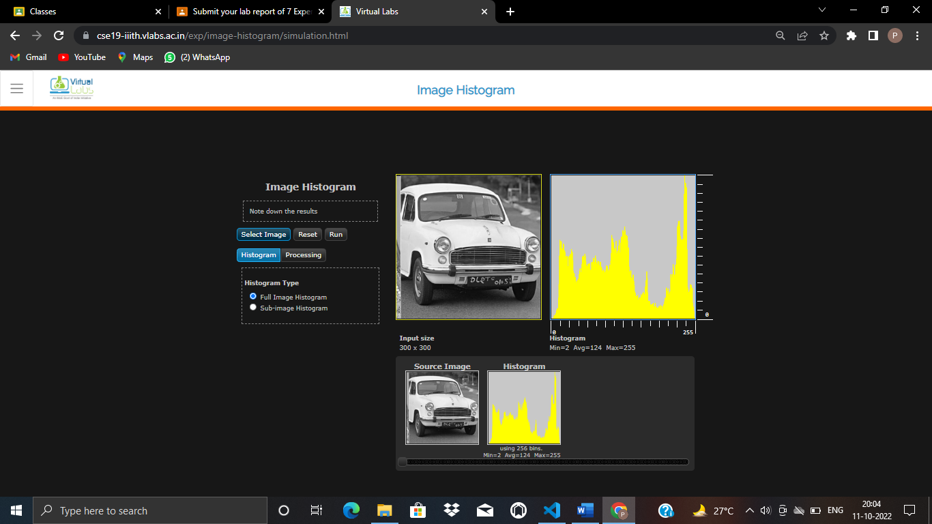

1. **Fourier Transform**

**Aim:** A number can be represented in many ways such as decimal, binary, hexadecimal etc. (ex. 15dec = 1111binary = Fhex). Likewise, a signal can also be represented in many ways that are more convenient for certain types of analysis. The most common representation is the Fourier transform which converts a spatial domain image into a spatial-frequency domain representation.

**Objective:** The main objective of this experiment is to understand some of the fundamental properties of the Fourier transform.

**Theory:** As we are interested in digital images, we concentrate on Discrete Fourier Transform (DFT). It can be used in a broad range of applications such as filtering, image restoration, compression and analysis etc.

The DFT does not contain all the frequencies which forms the image but only some samples which are sufficient to represent the information in spatial domain image. Given an image f[m,n] of size MxN, the mathematical expressions for DFT and inverse DFT (IDFT) are given below.

DFT:  (1)

IDFT: (2)

The Eq(1) can be interpreted as the value of F[k,l] at each point is obtained by multiplying the spatial image with the corresponding exponential function (base function) followed by summation. Basis functions are pure sinusoidals with increasing frequency. In Eq(2), term is corresponds to normalization constant.

The output of FT of an image is complex valued image which can be displayed by two images: magnitude and phase. Often only the magnitude of FT is displayed because it consists of the most of the information about the geometric structure of the image in spatial domain.

It is very easy to examine or process certain frequencies of the image in Fourier domain, it influences the geometric structure in the spatial domain.

In general, the FT image is shifted in such a way that the DC-value (i.e. the image mean) F[0,0] is displayed in the center of the image. The distance from the center is proportional to its corresponding frequency.

As an example, here we show the spatial (left) and frequency (right) domain representations of lena image.

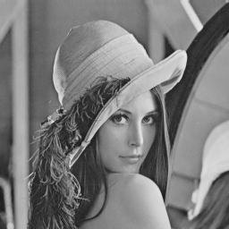 

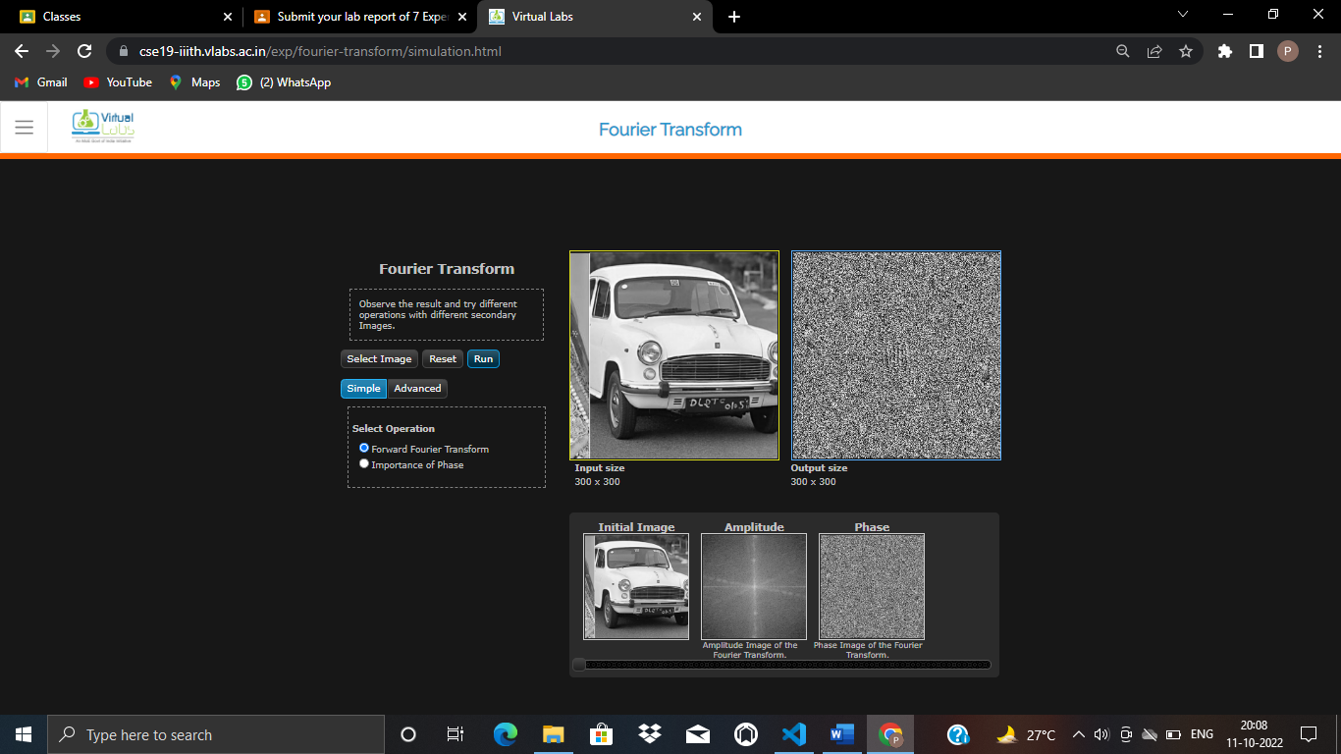

1. **Image Segmentation**

**Aim:** Image segmentation is a common task which arises in many situations such as extracting a face or a character in a text from an image before performing automatic recognition. Generally, it is used to separate the foreground pixels belonging to the object(s) of interest, from the background pixels. S egmentation aims to partition a given image into a set of regions having following properties: connectivity and homogeneity in terms of color or texture.

**Objective:**

1. Study the thresholding-based segmentation technique
   * Understand how the threshold can be selected from the image histogram and its effect on segmentation performance
   * Understand the difference between single and double thresholding
2. Study the region growing technique for segmentation
   * Understand how the seed selection affects segmentation performance

**Theory:** When the object(s) of interest in an image are clearly differentiated from the background in terms of brightness, then the image histogram can help in characterizing the foreground and background pixels. Fig.1 shows the histogram representing foreground and background regions of such an image. By selecting an appropriate gray-value point on the x-axis as a threshold, all pixels with value below the threshold can be considered to belong to the foreground and all those above belong to the background (and vice versa). This process is known as thresholding. There are many ways to threshold an image subject to the task in hand. In this experiment, few basic techniques of obtaining pixels of interest are explained.

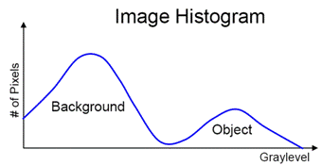

Figure 1 Histogram representation of the image.

**Single Threshold**

Let I(x,y) be the intensity value at pixel location (x,y) and T is the threshold value. The segmentation is done as follows. If I(x,y) >= T then it is labeled 1 in the output image otherwise it is labeled as 0. The pixel value corresponding to 1 and 0 depends on the application. For instance, Figure 2 shows a fingerprint image. By selecting a threshold value T=120 yields an output where 1 is set to white or pixel value of 255. Thus, in this case, the white pixels are background and black pixels are of the object of interest (fingerprint) or the foreground.

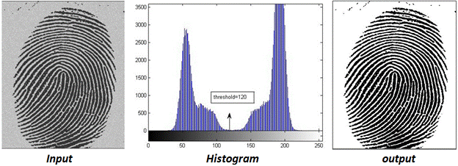

Figure 2: The binary output image as a result of single threshold with a value of 120.

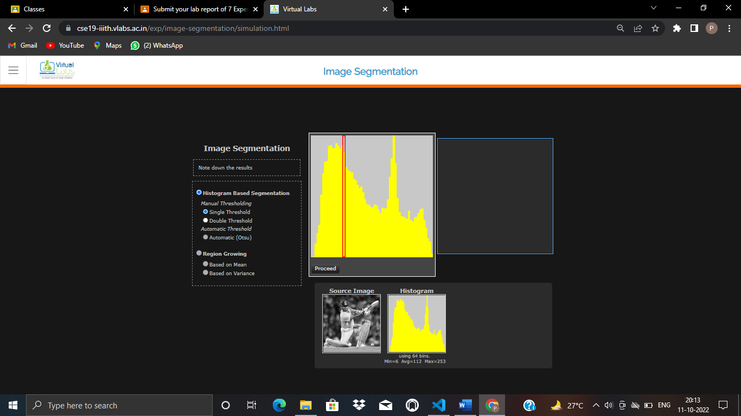

1. **Morphological Operation**

**Aim:** Mathematical morphology deals with set-theoretic operations. In image processing, morphological operations are typically used to extract information about forms and shapes of structures. These are neighbourhood operations which investigate an image using a template image of certain shape and size. This template is called a structuring element. The operation can be used to alter the shape (ex. make it bigger or smaller) or detect the presence of a particular form in a given image.

**Objective**: The objective of this experiment is to understand the basics of morphological operations which are used in analyzing the form and shape details of image structures.

**Theory:** Set- theory basics

Let A and B be sets with elements a Î A, and b Î B respectively and let x be a vector.

The Complement of A is defined as Ac = {d | dÏA}

The Difference between two sets A and B is defined as D = A-B = {d|d ÎA, d ÏB} = A ÇBc

The Translation of A by x is defined as Ax = {a + x | " a Î A}

The Reflection of A is defined as -B = {-b | " b Î B}

In the following, a structural element is denoted by set B.

Dilation

The Dilation of X by B is defined as X B = {x | -Bx Ç X ¹ f}

The result of dilation is a set of all locations x such that -Bx has at least 1 pixel within X.

